

ASUMBI GIRLS’ 2025 PREDICTION
CONFIDENTIAL KCSE EXAM
232/2
PHYSICS
PAPER 2
TIME: 2 HOURS

NAME……………………………………………………………………………….
SCHOOL……………………………………………… SIGN………………………..
INDEX NO………………………………………. ADM NO……………………

INSTRUCTIONS TO CANDIDATES
- Write your name, class and admission number in the spaces provided above
- Attempt ALL questions in sections A and B.
- All your answers must be written in the spaces provided in this question paper.
- All working must be clearly shown
- Non programmable silent electronic calculators and KNEC mathematics table may be used except where stated otherwise

for examiners use only
section | Question | Maximum score | Candidate’s score
A | 1 – 13 | 25
B | 14 | 10
 | 15 | 12
 | 16 | 12
 | 17 | 07
 | 18 | 08
 | 19 | 06
 | Total marks | 80

SECTION A ( 25 MARKS)
Answer ALL questions in this sections in the spaces provided.
1. The figure 1 below shows a positively charged metal plate with an earthing connection.
Using an arrow to show the direction of charges through the earth connection and explain the
final charge of the plate. (2marks)
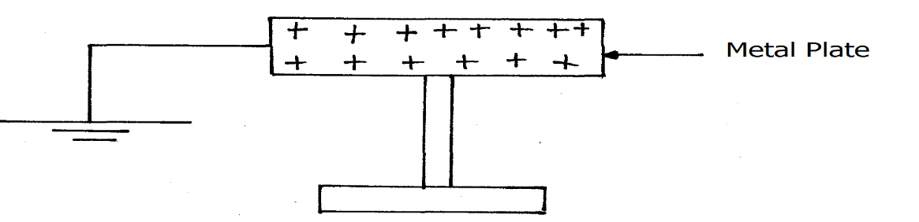Fig. 1
………………………………………………………………………………………………
………………………………………………………………………………………………
………………………………………………………………………………………………
………………………………………………………………………………………………

2. Figure 2 below shows a metre rule in equilibrium balanced by the magnet. The iron core is fixed to the bench
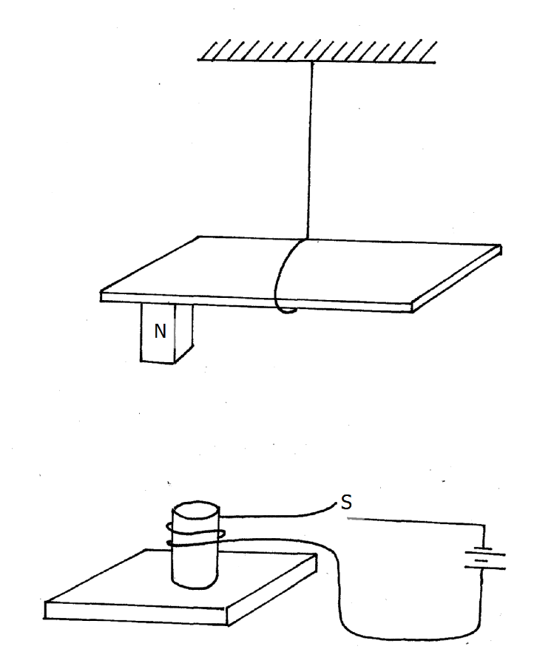 Fig.
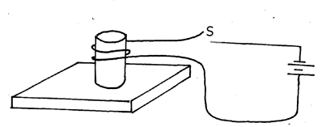

State and explain the effect on the metre rule when the switch S is closed. (2marks)
………………………………………………………………………………………………
………………………………………………………………………………………………
………………………………………………………………………………………………
………………………………………………………………………………………………

3. State two factors affecting the type of shadow formed by an object placed infront of a source of light. (2marks)
………………………………………………………………………………………………
………………………………………………………………………………………………
………………………………………………………………………………………………

4. Distinguish between intrinsic and extrinsic semi – conductors. (1mark)
………………………………………………………………………………………………
………………………………………………………………………………………………
………………………………………………………………………………………………

5. Figure 3 shows a galvanometer connected to a coil with a south pole of a permanent magnet approaching the coil.
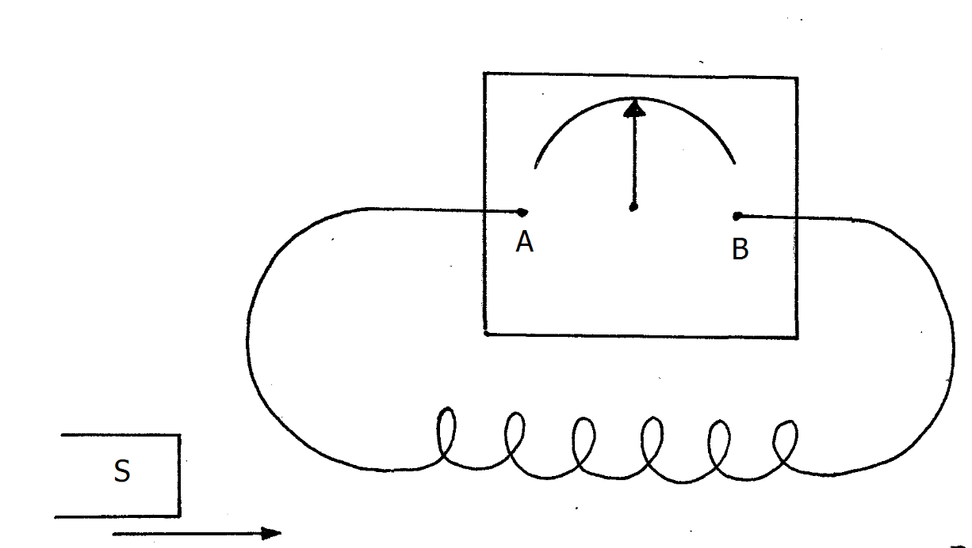Fig. 3
_{O}
Indicate the direction of the pointer on the galvanometer when the bar magnet is moved as
shown. (1mark)

6. What are the characteristics of the image formed when;
a) An object is placed beyond the centre of curvature of a concave mirror? (1mark)
………………………………………………………………………………………………
………………………………………………………………………………………………

b) An object is placed between the principal focus and the pole of a concave mirror? (1mark)
………………………………………………………………………………………………
………………………………………………………………………………………………

7. a) A coin is placed beneath a transparent block of thickness 10cm and refractive index 1.50.
Calculate the vertical displacement of the coin. (3marks)
………………………………………………………………………………………………
………………………………………………………………………………………………
………………………………………………………………………………………………
………………………………………………………………………………………………
………………………………………………………………………………………………

b) Kenya launched the use of optical fibres in communication recently. State why optical fibres are preferred to ordinary cables. (1mark)
………………………………………………………………………………………………
………………………………………………………………………………………………

8. A radiation of frequency 8.5 x 10¹⁴ Hz is incident on a metal emitting photoelectrons.
Determine the threshold wavelength if electrons accelerate to the anode at a velocity of 7.2 x 10⁵ m/s (3marks)
(Planck’s constant = 6.63 x 10⁻³⁴ Js, m_{e}= 9.11 x 10⁻³¹ Kg)
………………………………………………………………………………………………
………………………………………………………………………………………………
………………………………………………………………………………………………
………………………………………………………………………………………………

9. Figure 4 shows an electromagnet in an electric circuit.
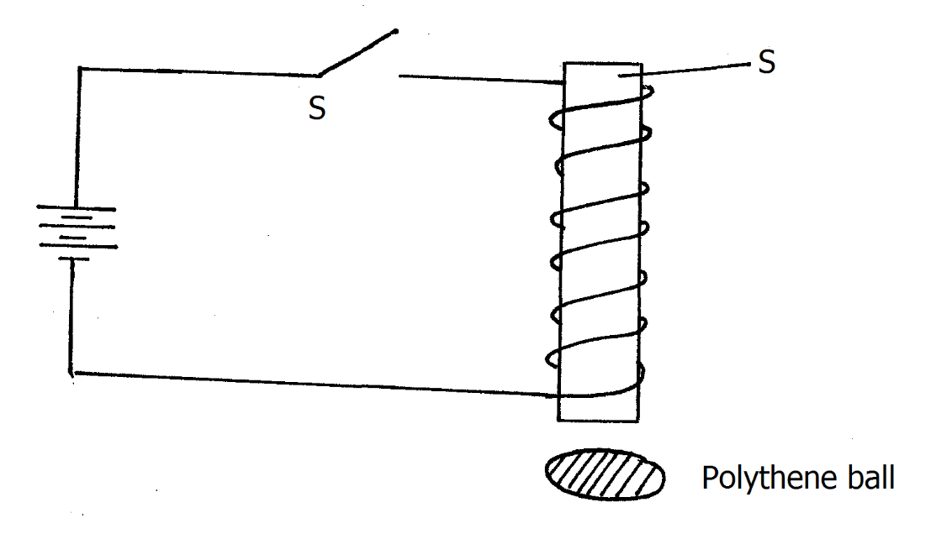Fig 4
A
a) State what happens to the polythene ball when the switch S is closed. (1mark)
………………………………………………………………………………………………
………………………………………………………………………………………………
………………………………………………………………………………………………

b) Why soft iron is preferred for material A than steel? (1mark)
………………………………………………………………………………………………
………………………………………………………………………………………………

10.Explain why the cathode of a CRO is coated with oxides of metals such as barium and
strontium. (1mark)
………………………………………………………………………………………………
……………………………………………………………………………………………………………………………………………………………………………………………

11. Distinguish between hard and soft X – rays. (2marks)
………………………………………………………………………………………………
………………………………………………………………………………………………
………………………………………………………………………………………………
………………………………………………………………………………………………

12. Figures 5 shows a simple water heater.
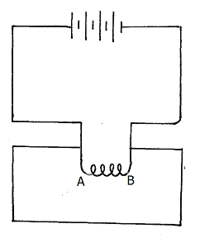Fig 5

Give a reason why AB is coiled. (1mark)
………………………………………………………………………………………………
………………………………………………………………………………………………

13.Arrange the following radiations in order increasing wavelength:
Ultra violet, microwaves, blue light, yellow light. (2mk)
………………………………………………………………………………………………
………………………………………………………………………………………………
………………………………………………………………………………………………

SECTION B ( 55 MARKS)
Answer ALL the questions in the spaces provided.
14.a) Some students wish to determine the focal length of a convex lens of thickness
0.6cm using an optical pin and a plane mirror. Figure 6 shows the experimental set up when there is no parallax between the pin and the image.
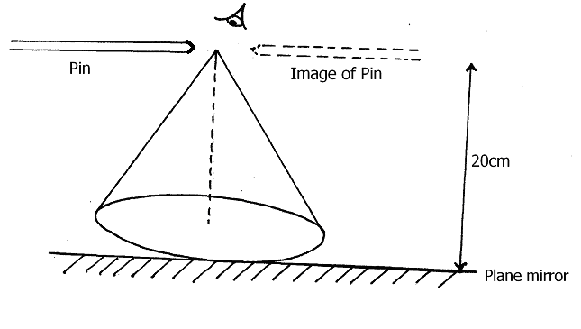
lens
Light rays
THICKNESS OF LENS = 0.6 cm
(i) Determine the focal length of the lens. (1mark)

(ii) Explain how you arrive at your answer. (2marks)
………………………………………………………………………………………………
………………………………………………………………………………………………
………………………………………………………………………………………………

b) An optician in Eldoret Hospital examined an eye of a patient and made the following observations:
Eye ball too small and the focal length of the eye lens too short.
(i) State the eye defect the patient could be having. (1mark)
………………………………………………………………………………………………
………………………………………………………………………………………………

(ii) Use a diagram to describe how the defect could be corrected. (2marks)
………………………………………………………………………………………………
………………………………………………………………………………………………
………………………………………………………………………………………………
………………………………………………………………………………………………
………………………………………………………………………………………………

c) The graph below shows the variation of 1/v and 1/u in an experiment to determine
the focal length of a lens.

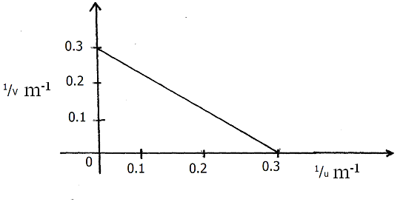

(i) Use the graph to determine the focal length. (3marks)
………………………………………………………………………………………………
………………………………………………………………………………………………
………………………………………………………………………………………………
………………………………………………………………………………………………

(ii) What is the power of the lens used? (1mark)
………………………………………………………………………………………………
………………………………………………………………………………………………

15.a)Define electric resistance. (1mark)
………………………………………………………………………………………………
………………………………………………………………………………………………

b) Figure 7. shows three resistors connected as shown.
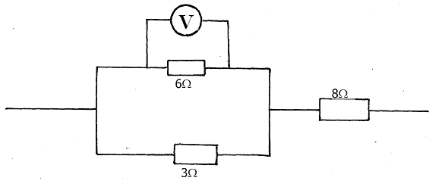 Fig 7
If the voltmeter reads 4v, find the
- Effective resistance. (2marks)
………………………………………………………………………………………………
………………………………………………………………………………………………
………………………………………………………………………………………………
………………………………………………………………………………………………

(ii) Current through the 3Ω resistor. (2marks)
………………………………………………………………………………………………
………………………………………………………………………………………………
………………………………………………………………………………………………
………………………………………………………………………………………………

(iii) Potential difference across the 8Ω resistor. (2marks)
………………………………………………………………………………………………
………………………………………………………………………………………………
………………………………………………………………………………………………
………………………………………………………………………………………………

c)i) What is meant by the term “lost volts”? (1mark)
………………………………………………………………………………………………
………………………………………………………………………………………………

ii) A cell supplies a current of 0.5A when connected to a 2Ω resistor and 0.25A
when connected to a 5Ω resistor.
Find the e.m.f and the internal resistance of the cell. (4marks)
………………………………………………………………………………………………
………………………………………………………………………………………………
………………………………………………………………………………………………
………………………………………………………………………………………………
………………………………………………………………………………………………

16.a)On the axes provided below, sketch a graph showing the variation of frequency with wavelength at constant velocity. (1mark)

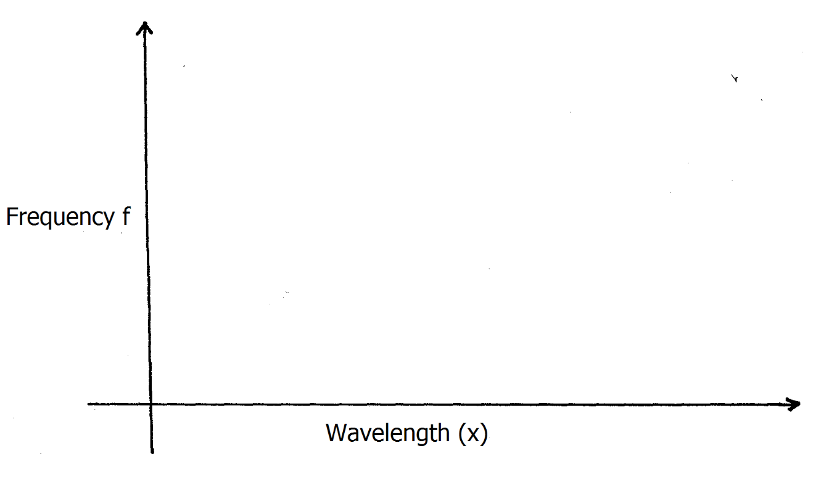
(λ)

b)Tv waves of frequency 6MHz travels with a speed of 3.0 x 10⁸ m/s.
What is the wavelength ?. (2marks)
………………………………………………………………………………………………
………………………………………………………………………………………………
………………………………………………………………………………………………
………………………………………………………………………………………………

c) Figure 8. shows circular waves approaching a concave reflector.

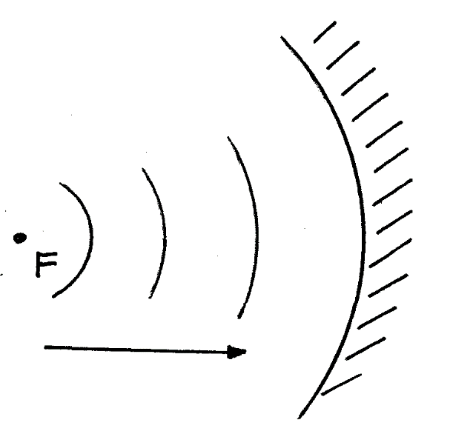 Fig. 8

Show the reflected waves and the missing part of incident wave (2marks)

d) State two conditions necessary for two progressive waves traveling in opposite directions to form stationary waves. (2marks)
………………………………………………………………………………………………
………………………………………………………………………………………………
………………………………………………………………………………………………

e) Figure 9 shows the set up used to demonstrate interference of sound.
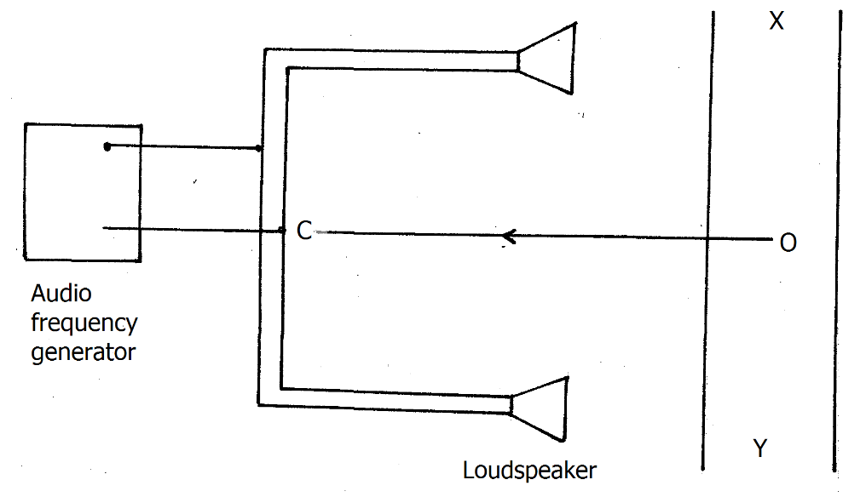 Fig 9

(i) An observer O, moves along XY.
State the observation(s) made. (1mark)
………………………………………………………………………………………………
………………………………………………………………………………………………
………………………………………………………………………………………………

- State what would be observed if a cathode ray oscilloscope is moved along line XY(2marks)
………………………………………………………………………………………………
………………………………………………………………………………………………
………………………………………………………………………………………………

(iii) What will a student hear if he moves along the line OC? (1mark)
………………………………………………………………………………………………
………………………………………………………………………………………………

(iv)Why are the loudspeakers connected to the same audio – frequency generator? ( 1mark)
………………………………………………………………………………………………
………………………………………………………………………………………………

17.a)State one factor that affects the capacitance of a capacitor. mark)
………………………………………………………………………………………………
………………………………………………………………………………………………

b) Figure 10. shows a circuit diagram with three capacitors.
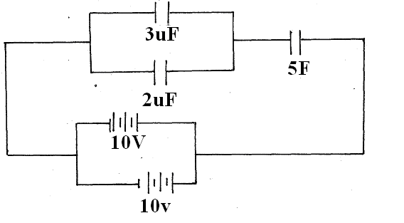fig 10

(i) Determine the effective capacitance of the arrangement. (2marks)
………………………………………………………………………………………………
………………………………………………………………………………………………
………………………………………………………………………………………………
………………………………………………………………………………………………

(ii)Find the energy stored in the combinations of capacitors. (3marks)
………………………………………………………………………………………………
………………………………………………………………………………………………
………………………………………………………………………………………………
………………………………………………………………………………………………
………………………………………………………………………………………………
………………………………………………………………………………………………
………………………………………………………………………………………………

c) Explain why it is not advisable to shelter under a tree when it is raining. (1mark)
………………………………………………………………………………………………
………………………………………………………………………………………………

18 a) State two dangers of high voltage transmission. (2marks)
………………………………………………………………………………………………
………………………………………………………………………………………………

b) A generator produces 150kW at a voltage of 5 kV. The voltage is stepped up to 60kV and transmitted through cables of resistance 150Ω to a step – down transformer in a substation. If both transformers are 80% efficient,
Calculate the:-
(i)Current through the transmission cables. (3marks)

(ii)Power lost during transmission. (3marks)

19.a)The half – life of cobalt – 60 is 5years.How long will a sample take for the activity to decrease to ¹/₁₆ of its original value. (3marks)

b) The graph below shows radioactive decay of iodine.
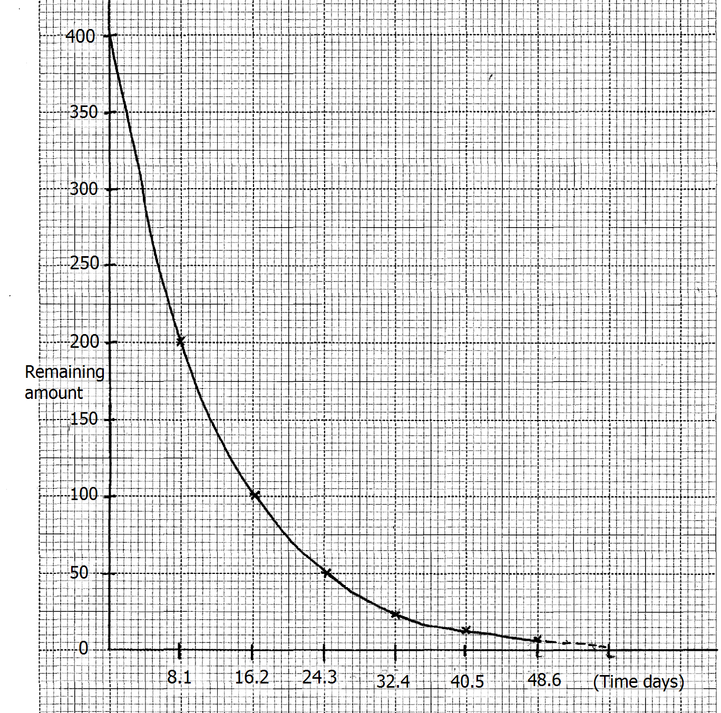
Use the graph to determine the:-
(i) fraction of the amount remaining after 16.2 days. (1marks)

(ii) determine the half – life of iodine. (1marks)

(iii) mass remaining after 17 days. (1mark)

END
THIS IS THE LAST PRINTED PAGE

